Nn

*Social prescribing enables primary care professionals to refer people to a range of local, non-clinical services via a link worker (****Social Prescriber****).*

*Social Prescribing at Alma Road Surgery*

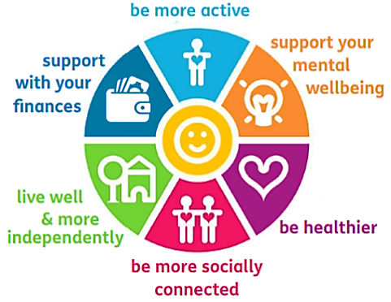

A Social Prescriber addresses a person’s needs and ***connects them to community groups and statutory services*** *for* ***practical and emotional support***.

*Social Prescribing can support with*

* Feeling **lonely**/**isolated**
* Having a **long term health condition**
* **Social**/**welfare issues** e.g. debt/benefit/housing issues
* Wanting a **lifestyle change** e.g. smoking/weight
* Joining/ accessing **community clubs**

***Exclusions****:* Under 18 years of age, individuals unsuitable for group related activities, other exclusions may apply.

*Employment, training and volunteering* Employment, training, and volunteering

*Healthy lifestyles and active lives*

*Befriending services*

*Education and learning*

*Counselling, + bereavement groups*

*Arts, music, outdoors and creative groups*

***Social Prescribing can link patients with services relating to:***

***Referrals****:*

* Referrals can be made **by any practice staff** – please ask you Gp, Practice Nurse or Receptionist
* Once referred, patients will be contacted by a Social Prescriber link worker

*It recognises the impact of social/ environmental factors on health and aims to support individuals to take greater control of their own health.*